Exercise 1: Implementing the Singleton Pattern
Logger.cs:-
using System;

namespace Exercise1_SingletonPatternExample
{
public sealed class Logger
{

private static Logger instance = null;
private Logger()
{
Console.WriteLine("Logger Instance Created");
}

public static Logger GetInstance()
{
if (instance == null)
{
instance = new Logger();
}

return instance;
}

public void Log(string message)
{
Console.WriteLine("Log: " + message);
}
}
}

Program.cs:-
using System;

namespace Exercise1_SingletonPatternExample
{
class Program
{static void Main(string[] args)
{
Logger logger1 = Logger.GetInstance();
Logger logger2 = Logger.GetInstance();

logger1.Log("This is the first log message.");
logger2.Log("This is the second log message.");

if (logger1 == logger2)
{
Console.WriteLine("Only one Logger instance exists.");
}
else
{
Console.WriteLine("Multiple Logger instances exist.");
}

Console.ReadKey();
}
}
}

Output:-
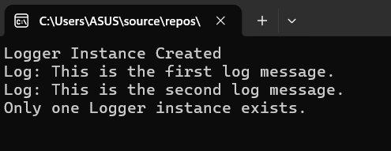

Exercise 2: Implementing the Factory Method Pattern
Program.cs:-
using System;

namespace FactoryMethodPatternExample
{
class Program
{
static void Main(string[] args)
{
DocumentFactory wordFactory = new WordFactory();
Document word = wordFactory.CreateDocument();
word.Open();

DocumentFactory pdfFactory = new PdfFactory();
Document pdf = pdfFactory.CreateDocument();
pdf.Open();

DocumentFactory excelFactory = new ExcelFactory();
Document excel = excelFactory.CreateDocument();
excel.Open();

Console.ReadKey();
}
}
}
